Task : Create a custom docker image for nginx and deploy it using docker-compose, where the volume mount should be at /var/opt/nginx location. Push the created custom docker image to your docker hub.

Docker Push

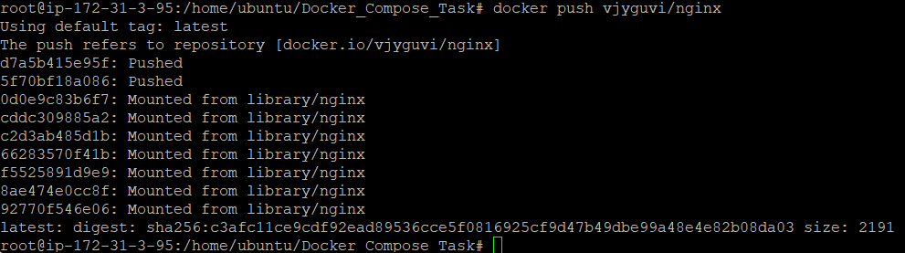

Docker Hub repo :

Image : docker pull vjyguvi/nginx

Web output:

